**Duplicate email address issue**

If your email address has already being recognised by Patient Access due to registration at a previous practice you need to follow the following instructions.  The reason for this is that if the previous surgery is fairly local we all share a Database and records are archived not deleted.

Although your patient account has been cancelled at your previous surgery the database is only archived and the email address is still there.

You can delete your Patient Access account by logging on to Patient Access <https://www.patientaccess.com/> and clicking on the ***Support Centre*** link in the top right of the screen.



cid:image006.jpg@01D4E2FF.B673D790

Then click on ***Contact support*** in the top right of the screen.



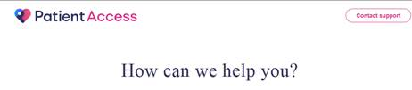

Fill in the form below with your details, pick ***Account deletion*** from the drop down box and write “***Email already in use***” in the Details of your query box.

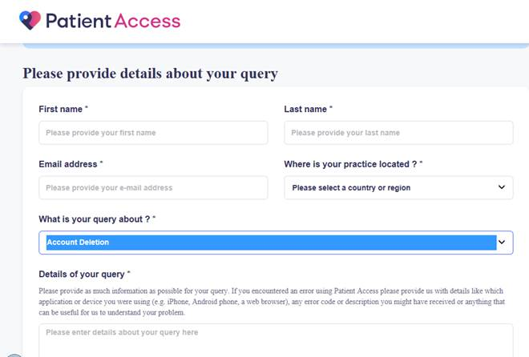

You will then receive an email asking you to click on the link to confirm deletion of the account.

Once you have completed this process you will need register for Patient Access again with the details that we gave you at our surgery.